**SCREENSHOTS**

**1.Azure Databricks Workspace Loading**

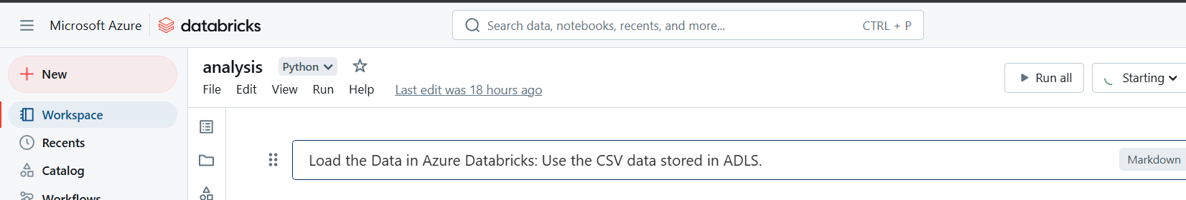

**2.File Path Configuration for Data Ingestion**

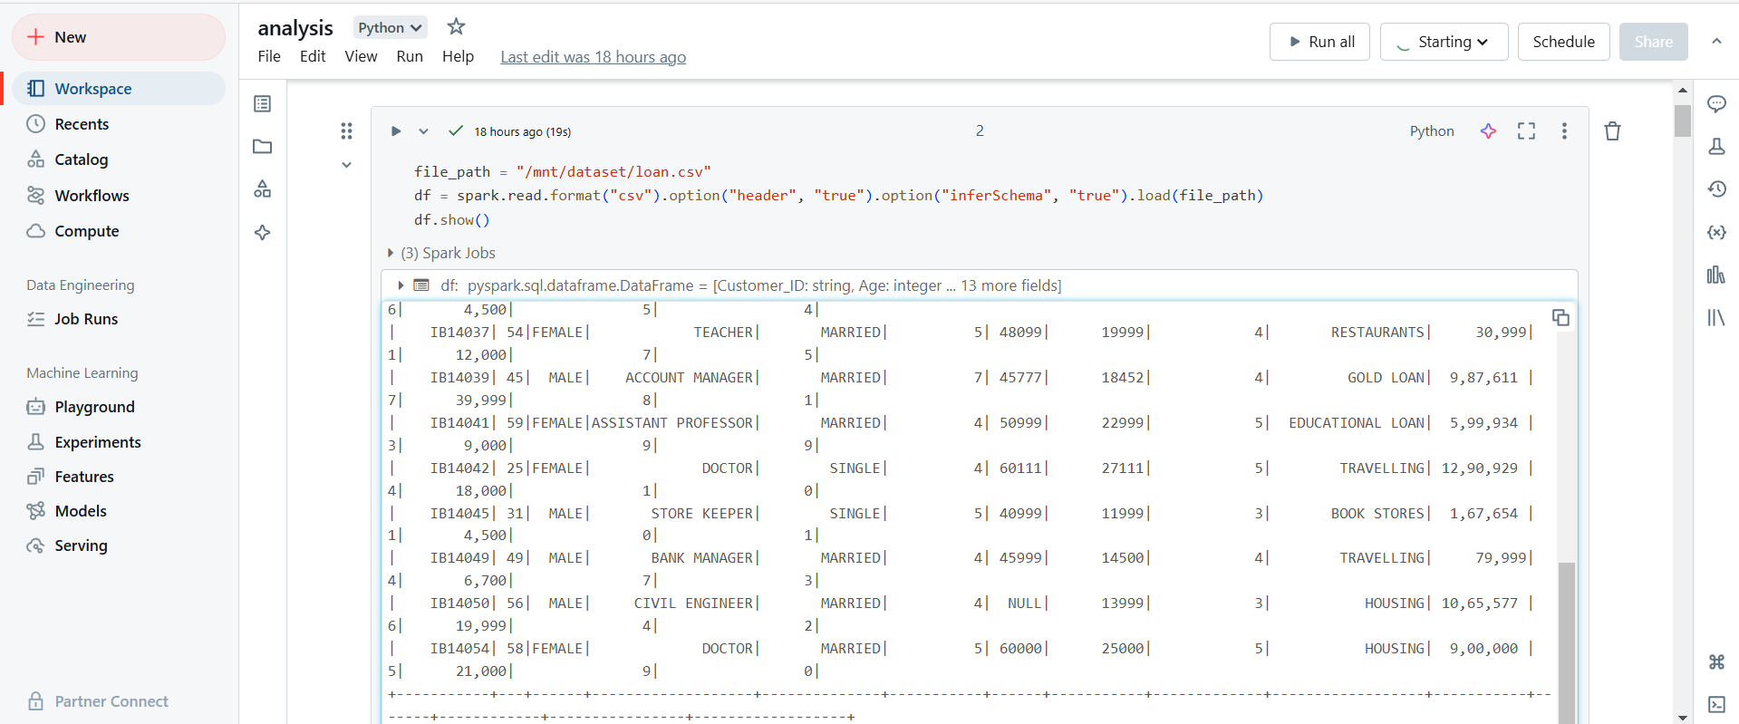

**3.Data Cleaning and Transformation Using PySpark SQL Function**

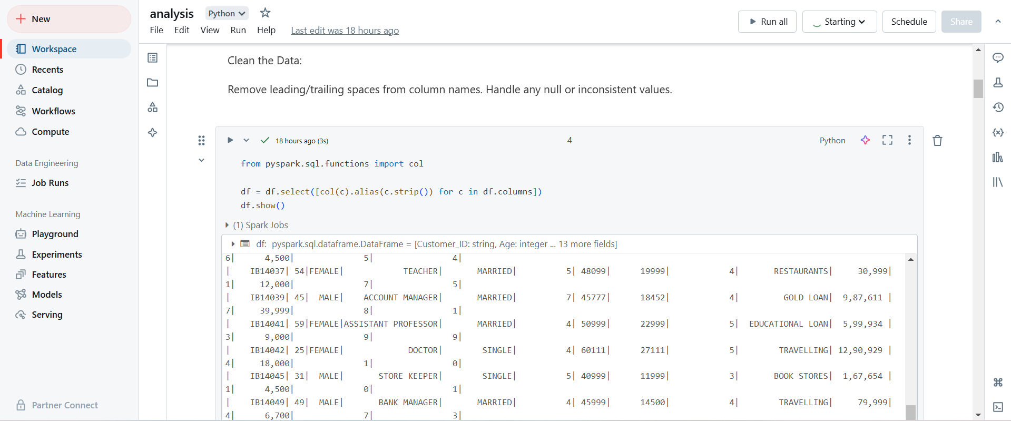

**4. Databricks Job Stages and Execution Details**

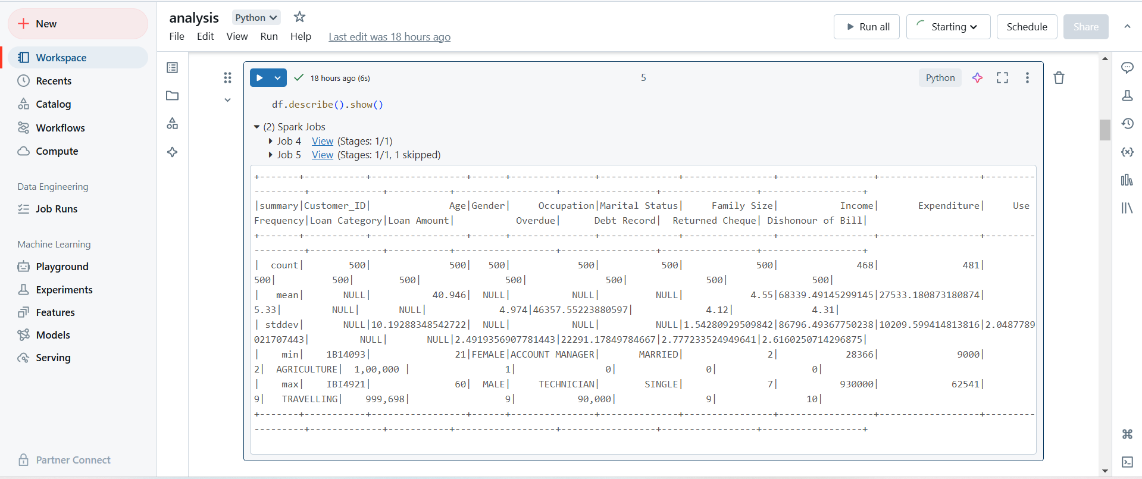

**5.Income Distribution Visualization**

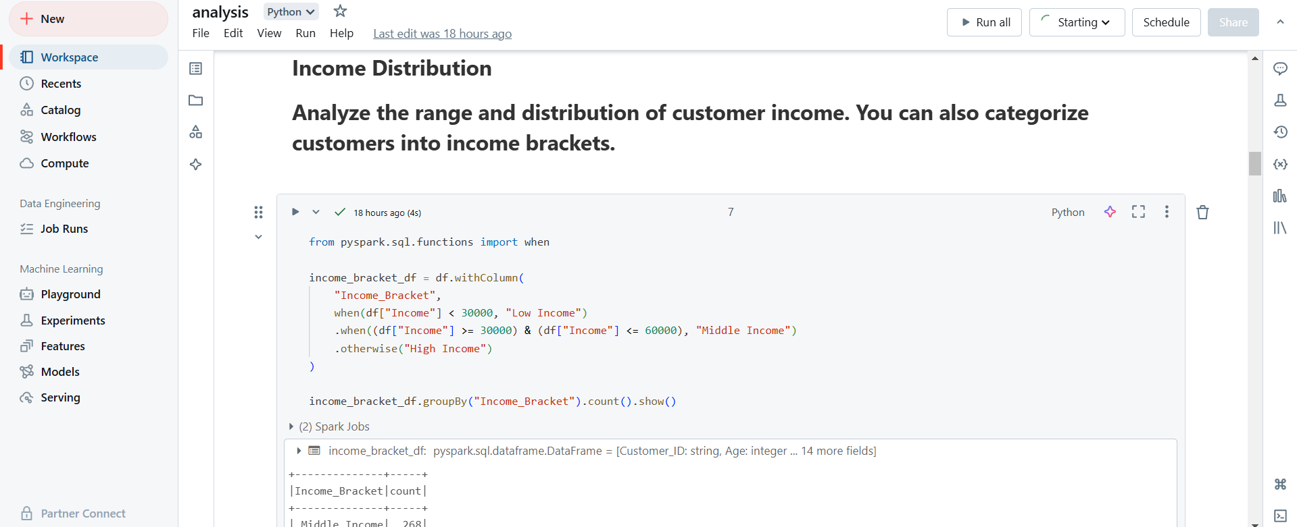

**6.Income Distribution Display**

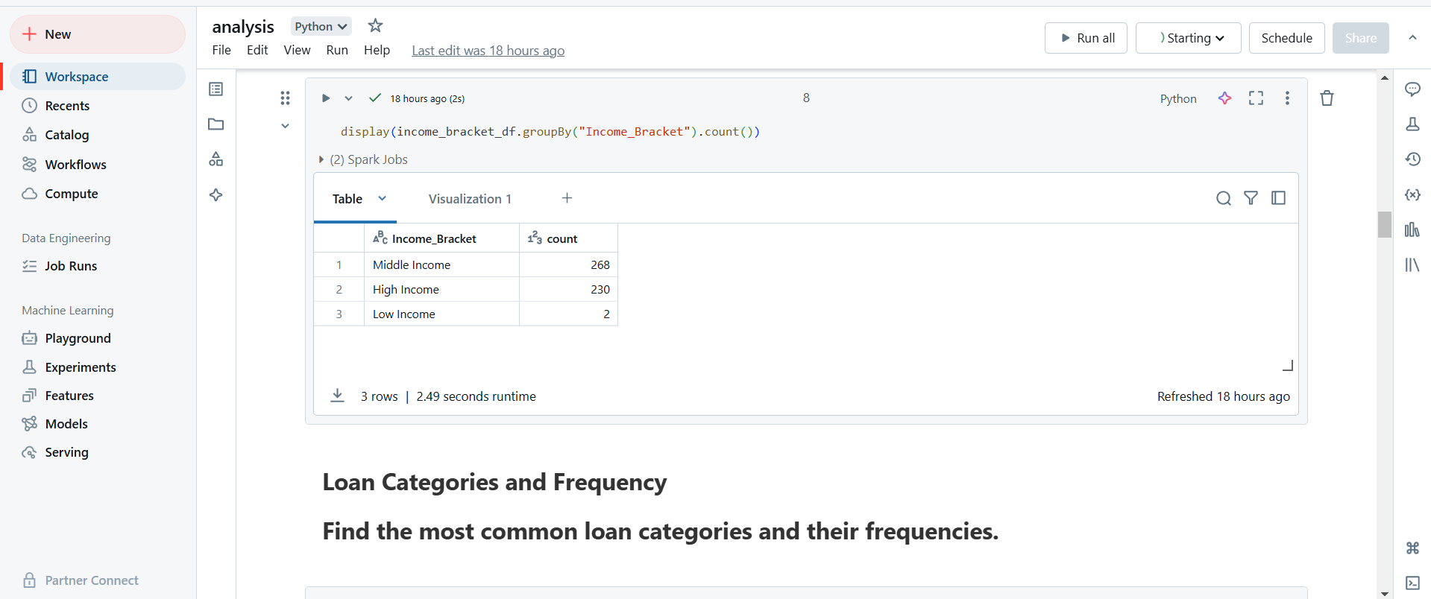

**7.Income Distribution Visualization**

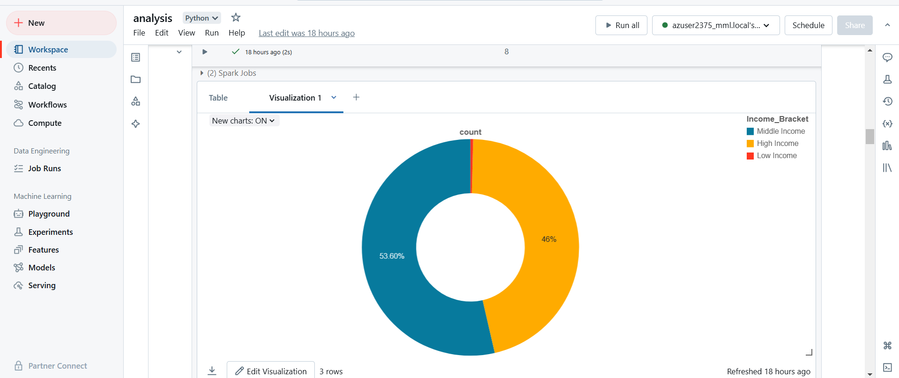

**8.Loan Categories Visualization**

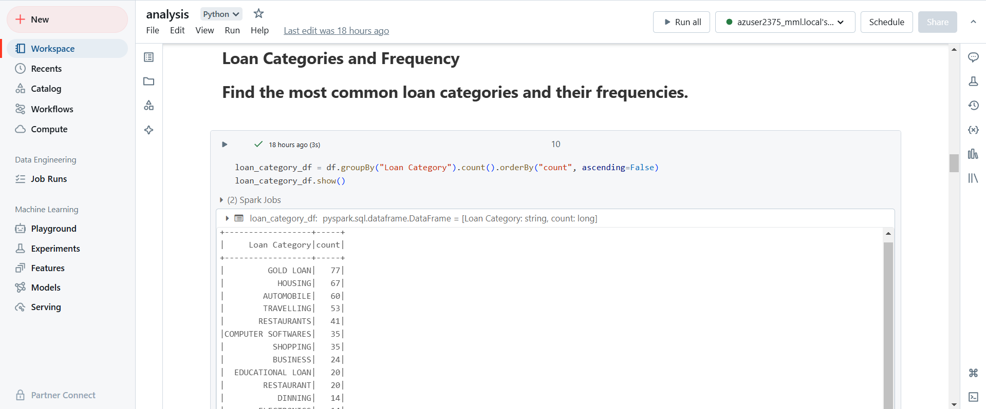

**9.Loan Category Classification**

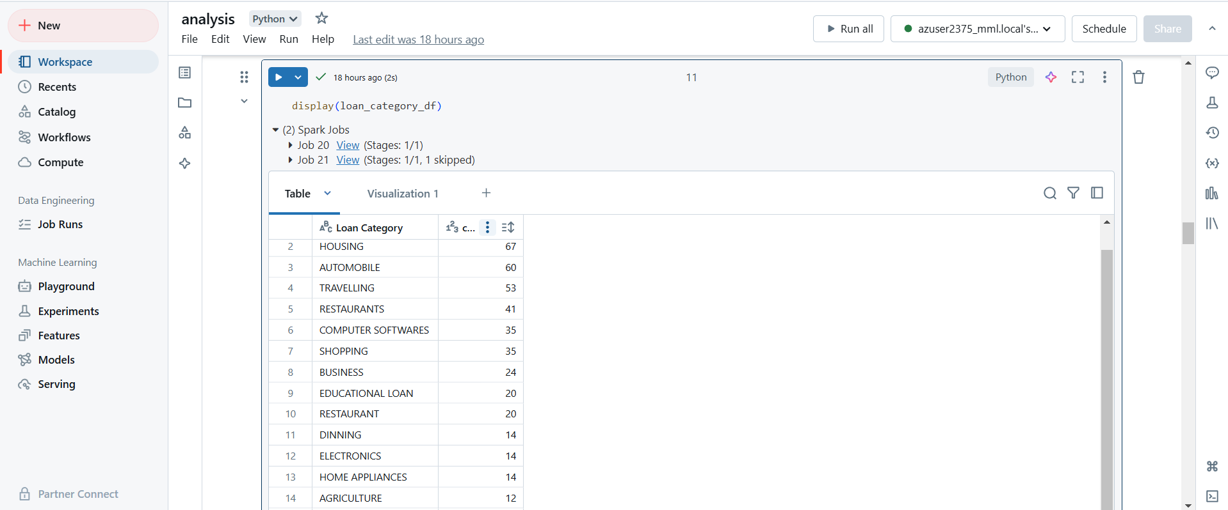

**10.Loan Data Classification Visualization**

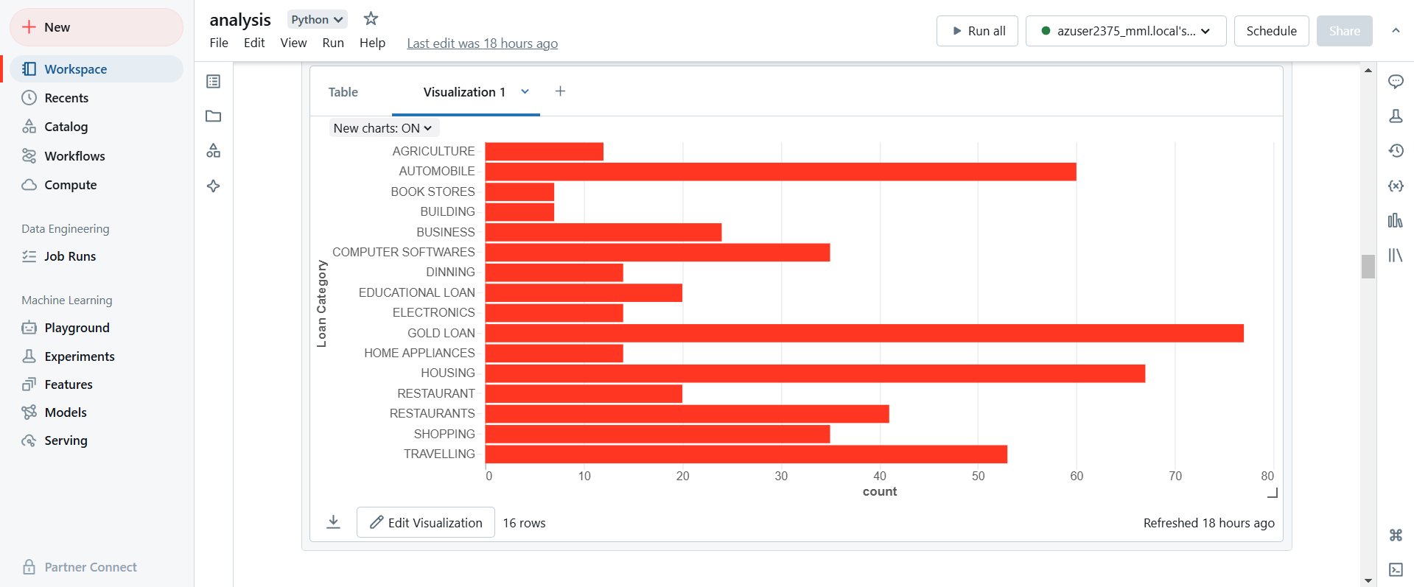

**11.Overdue Loan Analysis**

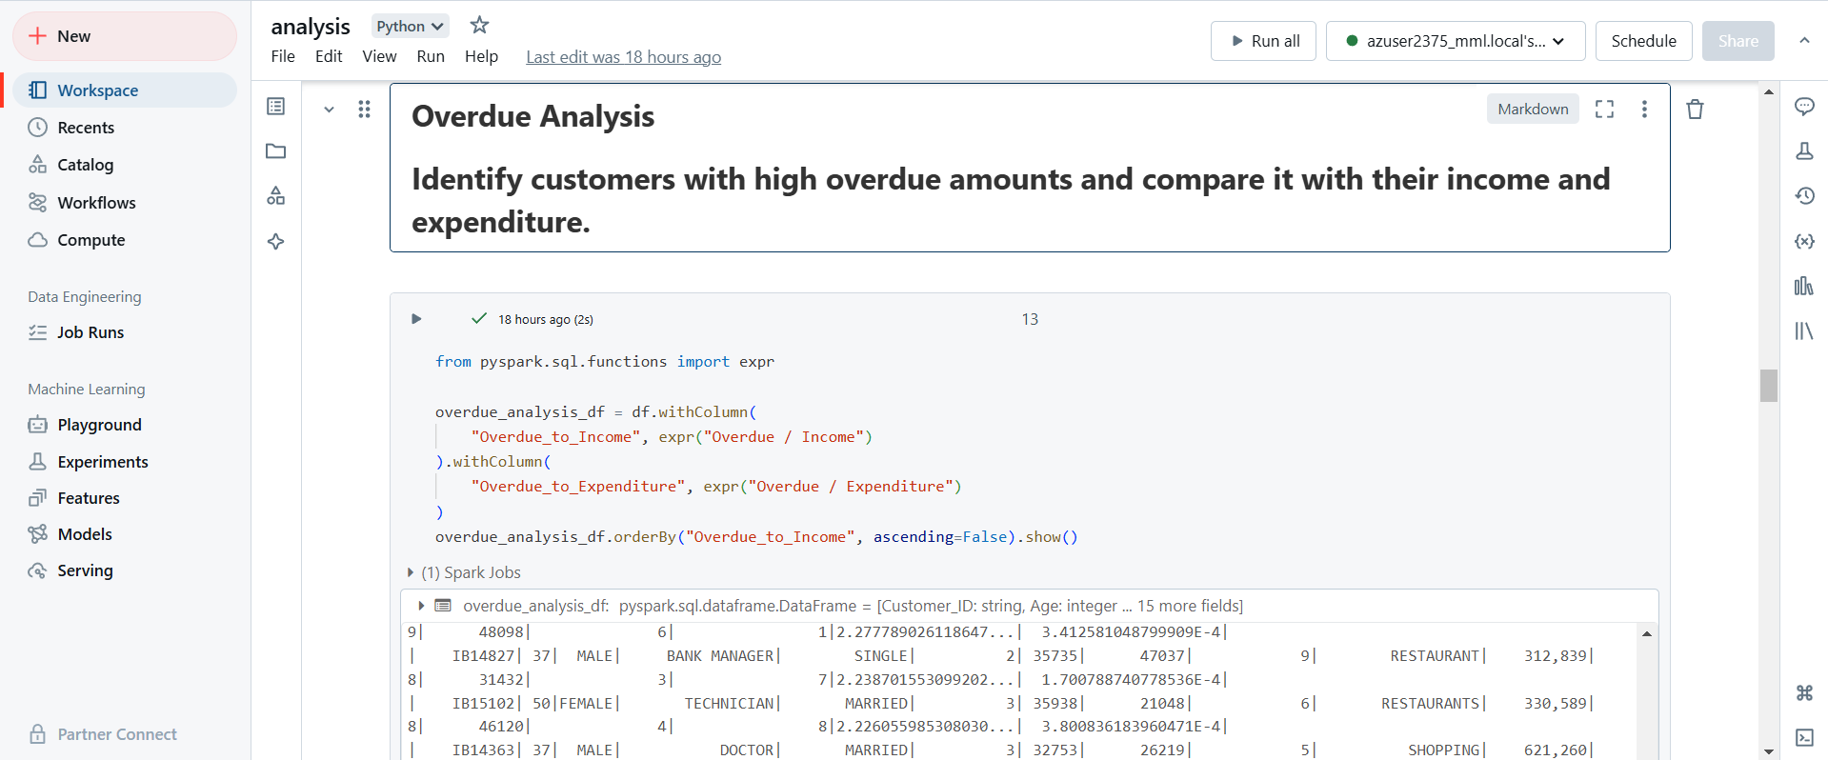

**12.Loan Prediction Model**

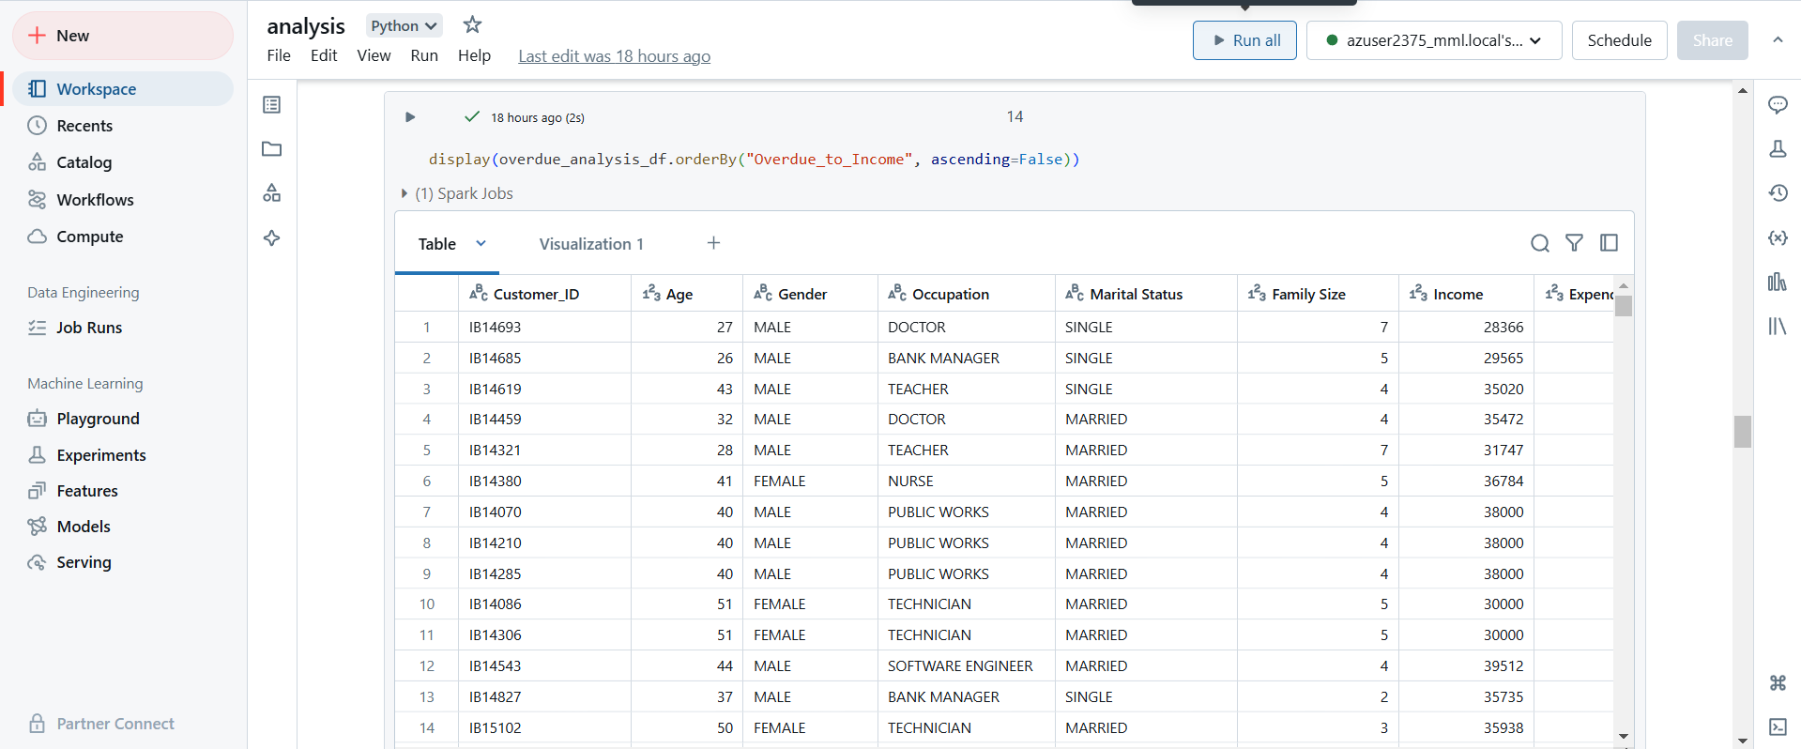

**13.Overdue Loan Repayment Visualization**

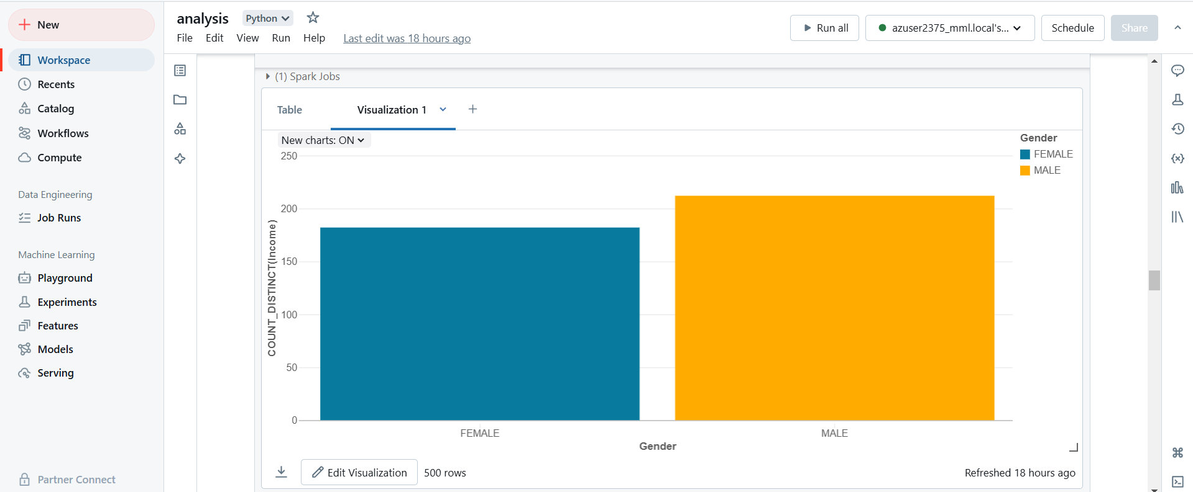

**14.Expenditure Patterns Analysis**

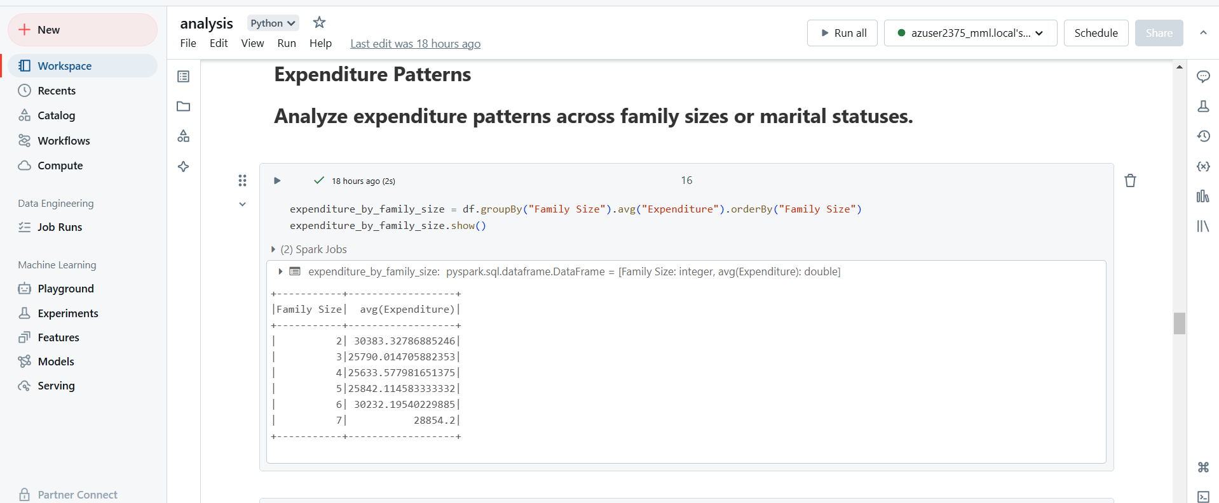

**15.Loan Default Prediction**

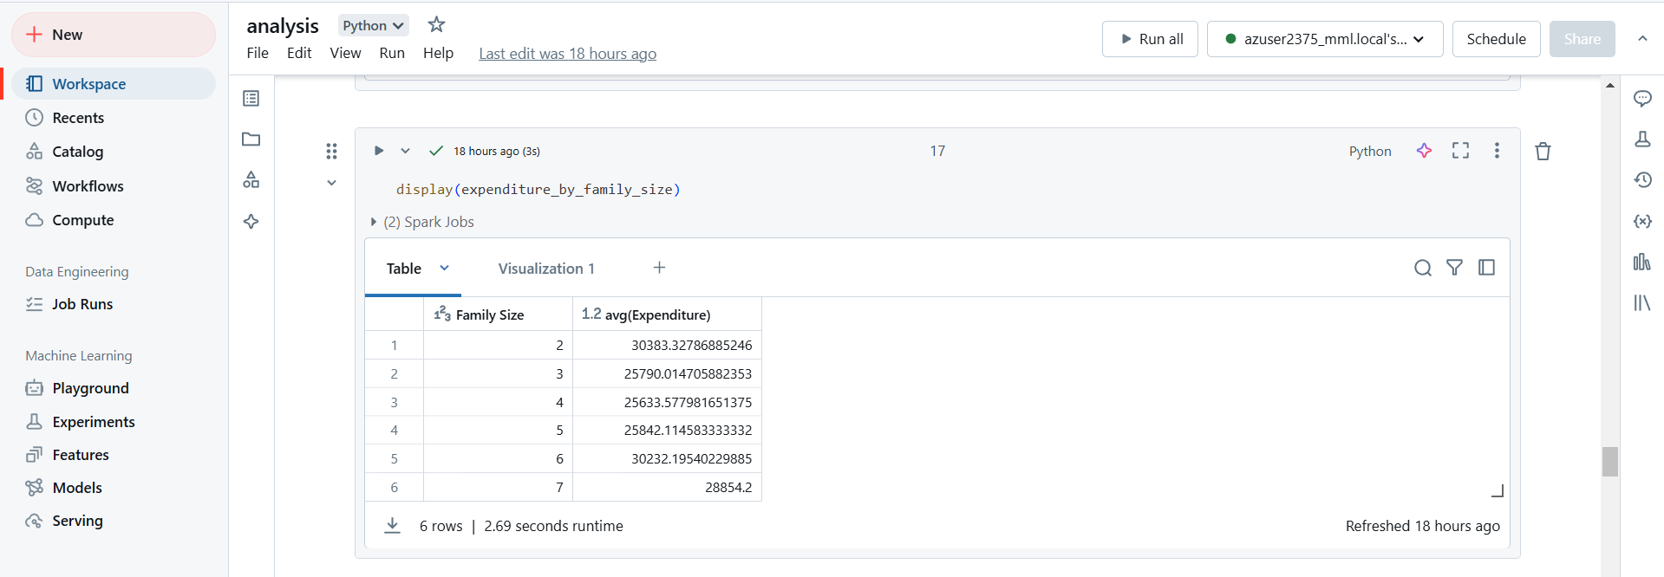

**16.Loan Data Overview Visualization**

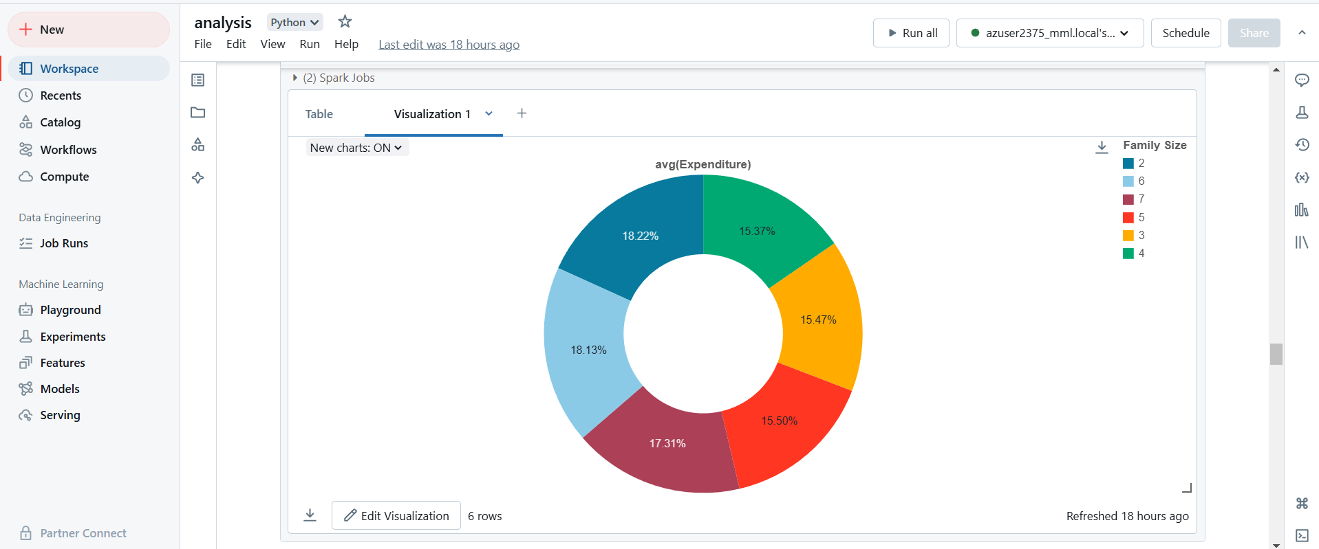

**17.Debt and Payment Issues Analysis**

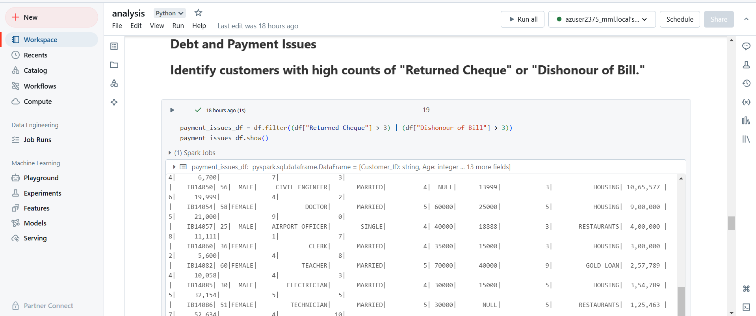

**18.Income and Expenditure Analysis**

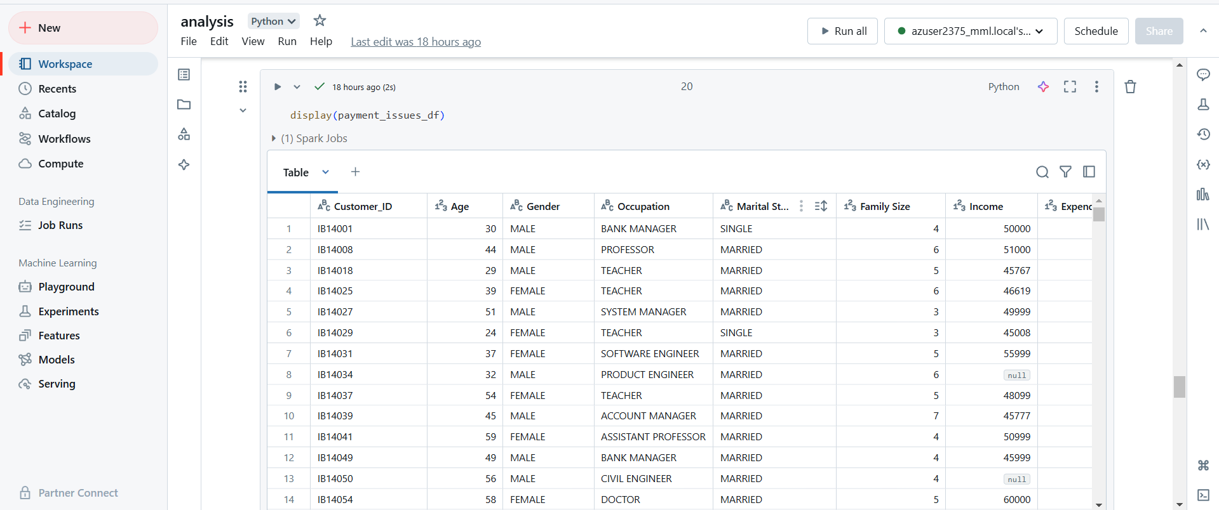

**19.Data Transformation Analysis**

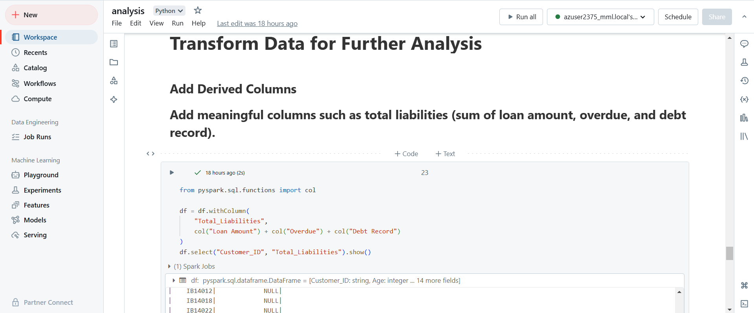

**20.Customer Segmentation Analysis**

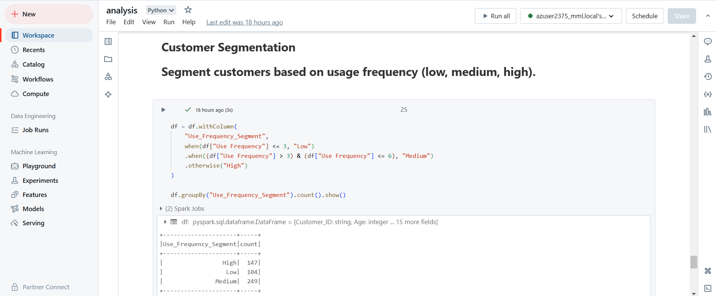

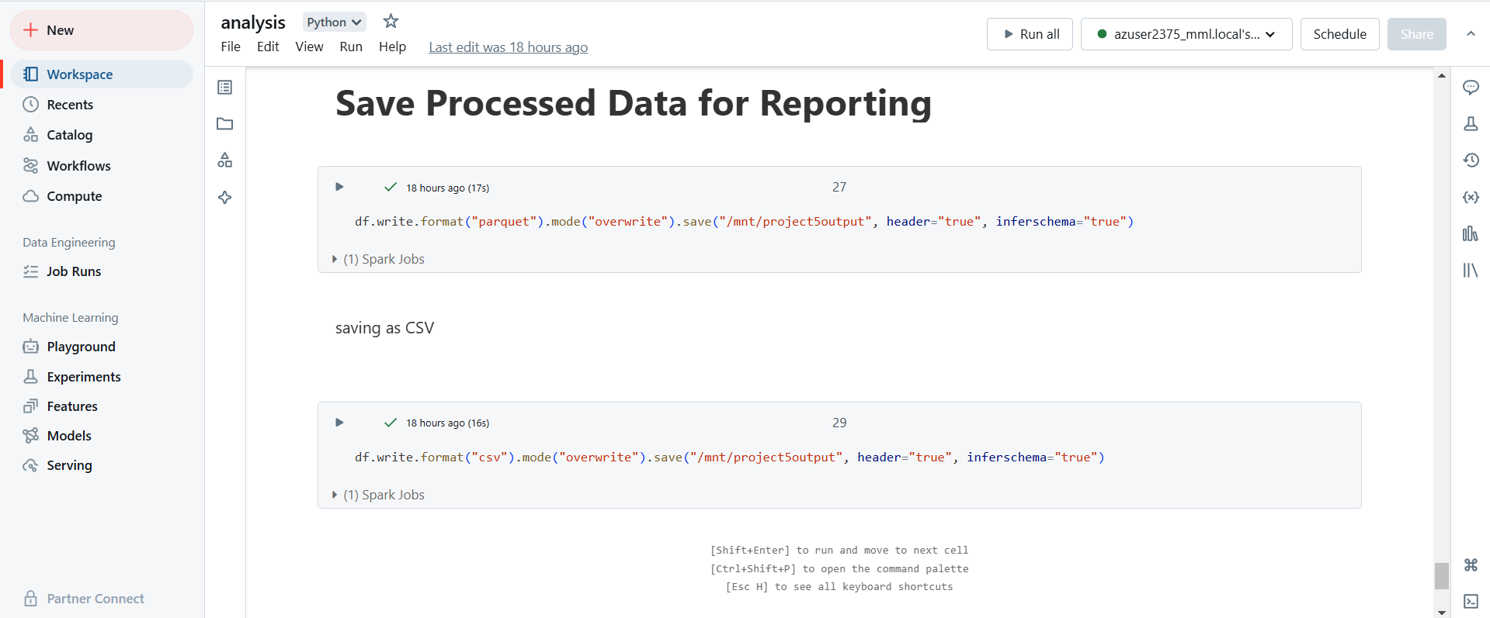

**21.Saving Processed Data for Reporting**